Data pre processing

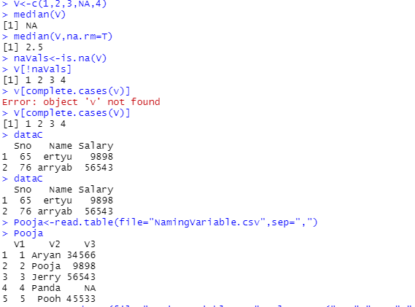

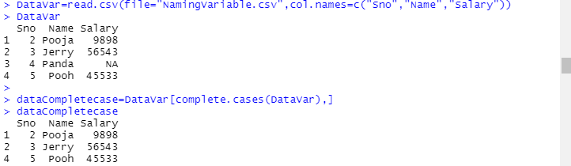

Install.packages(“Hmisc”)

Library(hmisc)

